Project Design Phase-II
Data Flow Diagram & User Stories

Date | 11 June 2026
Team ID
Project Name | ShopEZ: E-Commerce Application
Maximum Marks | 4 Marks

Data Flow Diagrams:
A Data Flow Diagram (DFD) is a traditional visual representation of the information flows within a system.
A neat and clear DFD can depict the right amount of the system requirement graphically.
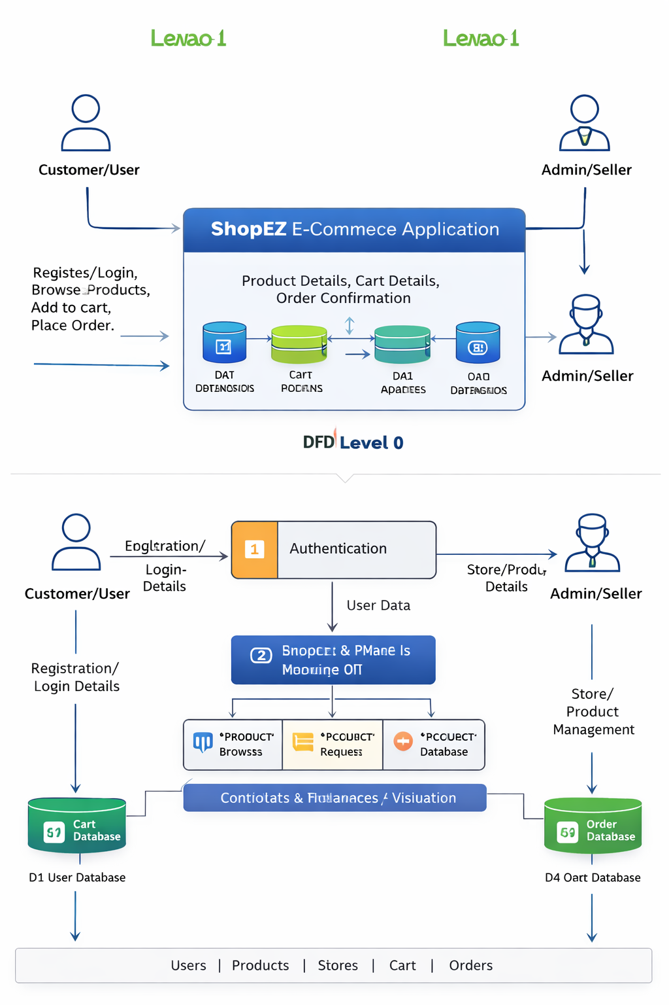
It shows how data enters and leaves the system, what changes the information,
and where data is stored.
DFD Level 0 and DFD Level 1

User Stories
User Type | Functional Requirement (Epic) | User Story Number | User Story / Task | Acceptance Criteria | Priority | Release
Customer Web User | Registration | USN-1 | As a user, I can register for the application by entering my name, email, password, and confirming my password. | User account is created and user can access the application. | High | Sprint-1
Customer Web User | Registration | USN-2 | As a user, I can see validation messages when required registration fields are empty or invalid. | System displays proper validation messages for invalid input. | High | Sprint-1
Customer Web User | Login | USN-3 | As a user, I can log into the application by entering my email and password. | User is logged in and redirected to the homepage/dashboard. | High | Sprint-1
Customer Web User | Login | USN-4 | As a user, I can see an error message when wrong login credentials are entered. | System displays an invalid email or password message. | High | Sprint-1
Customer Web User | Dashboard | USN-5 | As a user, I can view the homepage/dashboard after login. | Homepage/dashboard displays products and navigation options. | High | Sprint-1
Customer Web User | Products | USN-6 | As a customer, I can view the list of available products. | Product list displays product name, price, image, and details. | High | Sprint-2
Customer Web User | Products | USN-7 | As a customer, I can view detailed information about a selected product. | Product details page displays description, price, image, and availability. | High | Sprint-2
Customer Web User | Products | USN-8 | As a customer, I can search or filter products. | Products are filtered according to search keyword or category. | Medium | Sprint-2
Customer Web User | Store | USN-9 | As a customer, I can view store information. | Store page displays store name, address/contact, and available products. | Medium | Sprint-2
Customer Web User | Cart | USN-10 | As a customer, I can add products to my cart. | Selected product is added to cart successfully. | High | Sprint-3
Customer Web User | Cart | USN-11 | As a customer, I can view all products added to my cart. | Cart page displays selected products, quantity, and total amount. | High | Sprint-3
Customer Web User | Cart | USN-12 | As a customer, I can update product quantity in my cart. | Quantity changes and total price updates correctly. | High | Sprint-3
Customer Web User | Cart | USN-13 | As a customer, I can remove products from my cart. | Product is removed and cart total is recalculated. | High | Sprint-3
Customer Web User | Order | USN-14 | As a customer, I can place an order from my cart. | Order is created and saved successfully. | High | Sprint-3
Customer Web User | Order | USN-15 | As a customer, I can view order confirmation after placing an order. | System displays order confirmation message/details. | High | Sprint-3
Customer Web User | Order | USN-16 | As a customer, I can view my order history. | User can see previous orders with status and order details. | Medium | Sprint-3
Administrator | Product Management | USN-17 | As an admin, I can add a new product. | New product is saved and visible in product list. | High | Sprint-2
Administrator | Product Management | USN-18 | As an admin, I can update existing product details. | Updated product information is saved and displayed correctly. | High | Sprint-2
Administrator | Product Management | USN-19 | As an admin, I can delete a product. | Deleted product is removed from product list/database. | Medium | Sprint-2
Administrator | Store Management | USN-20 | As an admin/seller, I can add a new store. | Store is created and stored successfully. | High | Sprint-2
Administrator | Store Management | USN-21 | As an admin/seller, I can update store details. | Store details are updated and displayed correctly. | High | Sprint-2
Administrator | Store Management | USN-22 | As an admin/seller, I can delete a store. | Store is deleted from the system. | Medium | Sprint-2
Administrator | Order Management | USN-23 | As an admin, I can view all customer orders. | Admin can see customer order list with order details. | High | Sprint-4
Administrator | Order Management | USN-24 | As an admin, I can update order status. | Order status is updated successfully. | High | Sprint-4
Administrator | User Management | USN-25 | As an admin, I can view registered users. | Admin can see list of registered users. | Medium | Sprint-4
System | Security | USN-26 | As a system, I can restrict admin pages from normal users. | Only authorized admin users can access admin features. | High | Sprint-4
System | Validation | USN-27 | As a system, I can validate forms on frontend and backend. | Invalid or empty data is rejected with proper messages. | High | Sprint-4
System | Database | USN-28 | As a system, I can store user, product, store, cart, and order data in MongoDB. | Data is saved, retrieved, updated, and deleted correctly. | High | Sprint-1
System | Deployment | USN-29 | As a user, I can access the deployed e-commerce application online. | Application opens successfully from hosted URL. | High | Sprint-4

